Terraform challenge
1.Create an EC2 Instance on AWS Cloud using the below-mentioned ubuntu AMI and instance_type. Or, (You can use of your choice as well) Ami = "ami-0461b1436c9b3c1a3" instance_type = "t2. micro"
create a main.tf file
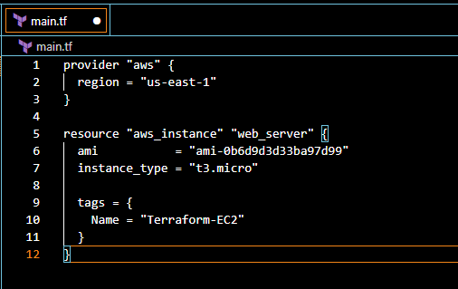
terraform. Init
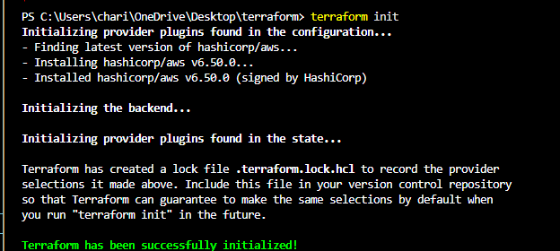
terraform plan
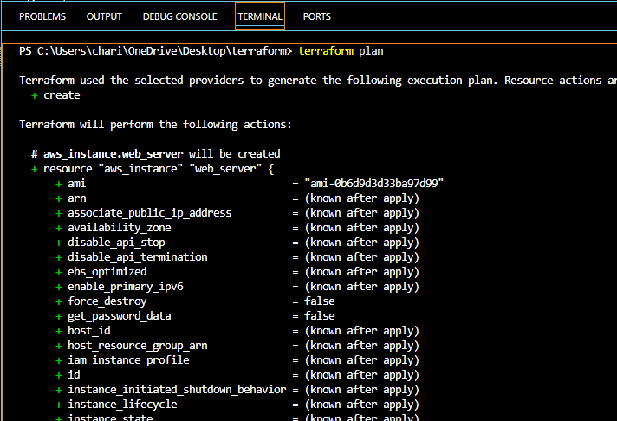
terraform apply
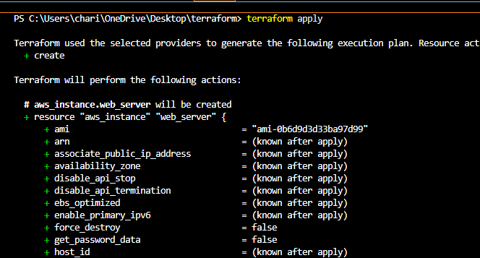
EC2 instance created successfully
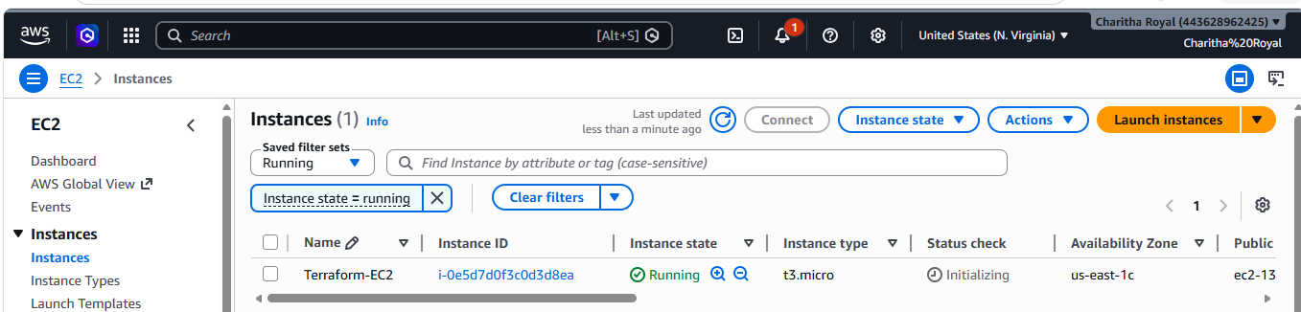
ubuntu image
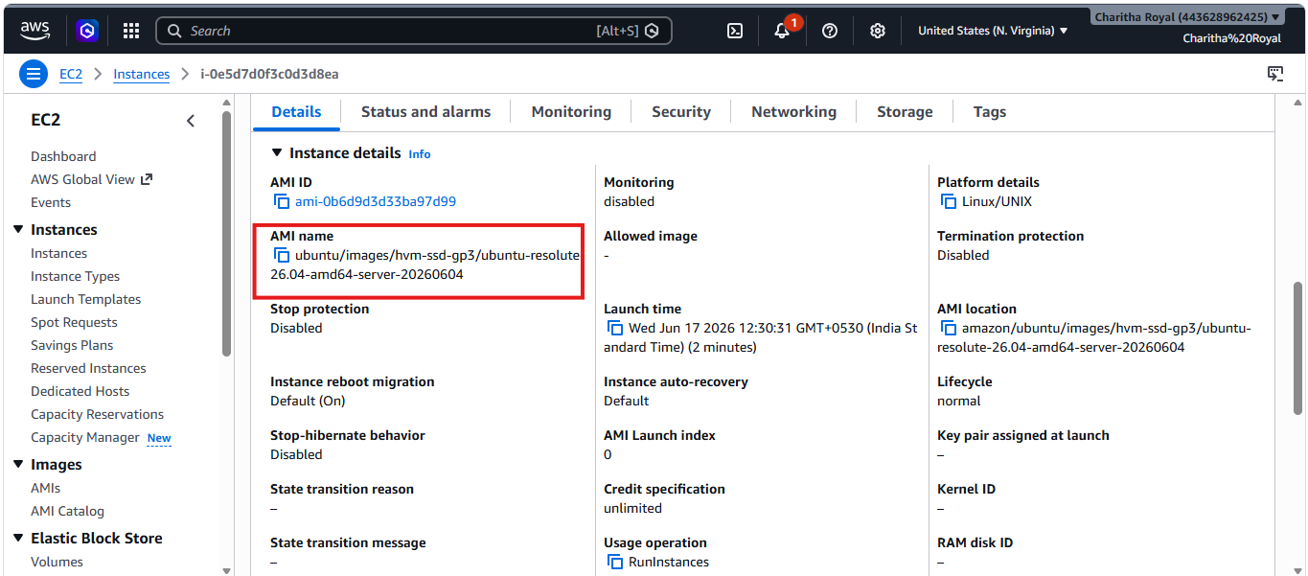
2.Install a web server on the same EC2 Instance. The web server should listen on port 8080.
In main.tf file we Created an EC2 instance with Terraform and configured a Nginx web server to run on port 8080
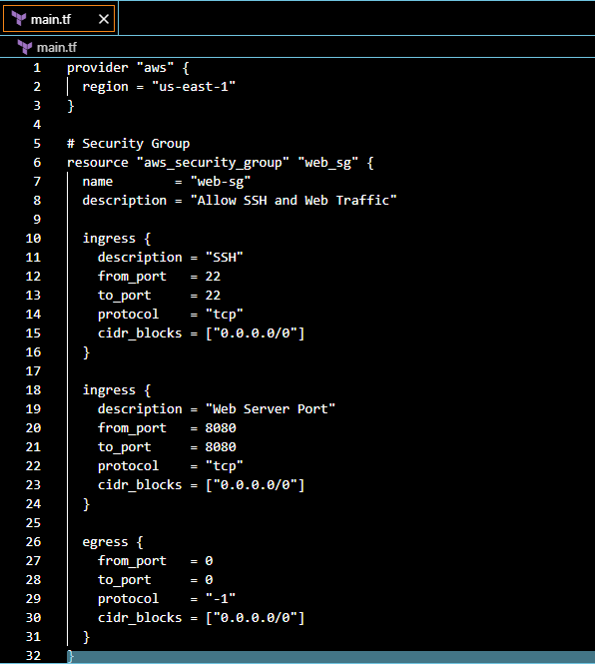
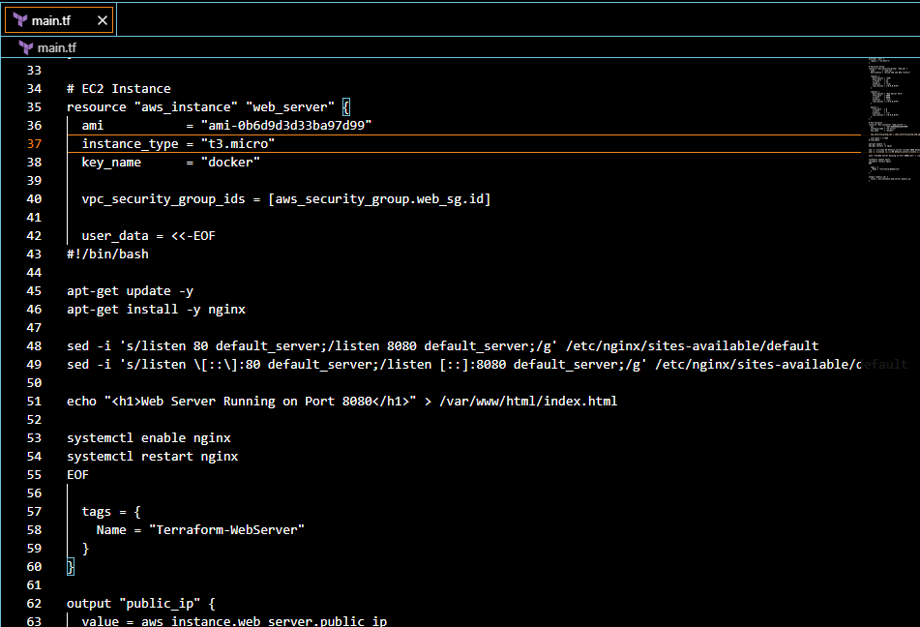
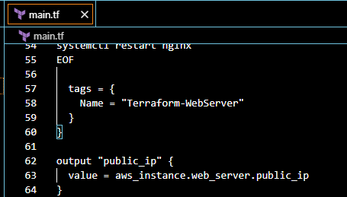
terraform plan
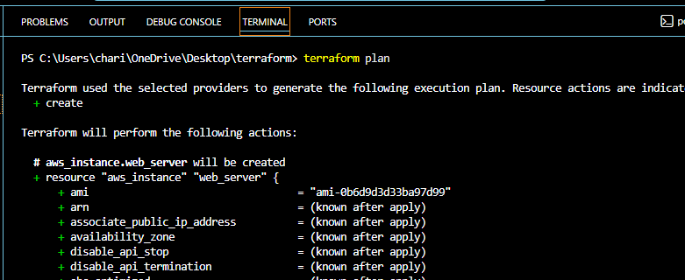
terraform apply
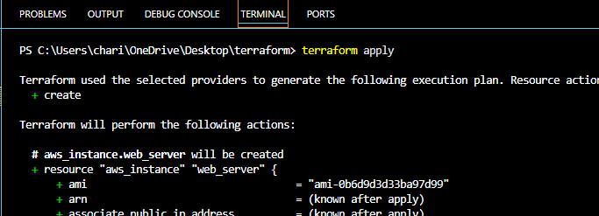
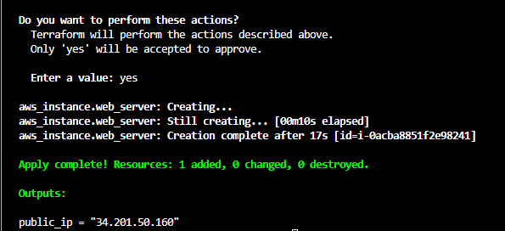
Verified with port 8080 it accessed successfully
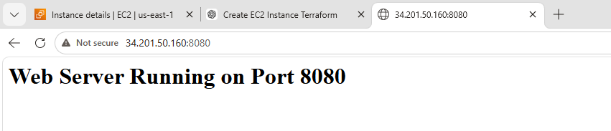
3.Create a Docker-compose file for the project:https://github.com/betawins/cricbuzz-docker-hello-world.gitand point it to port 8000.
4.Make the web server point to the above service so that 8080 returns the response from the Docker service.
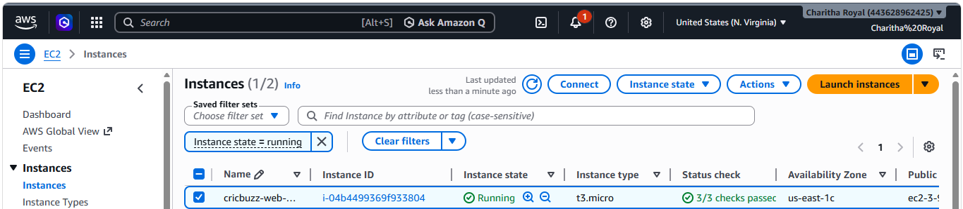
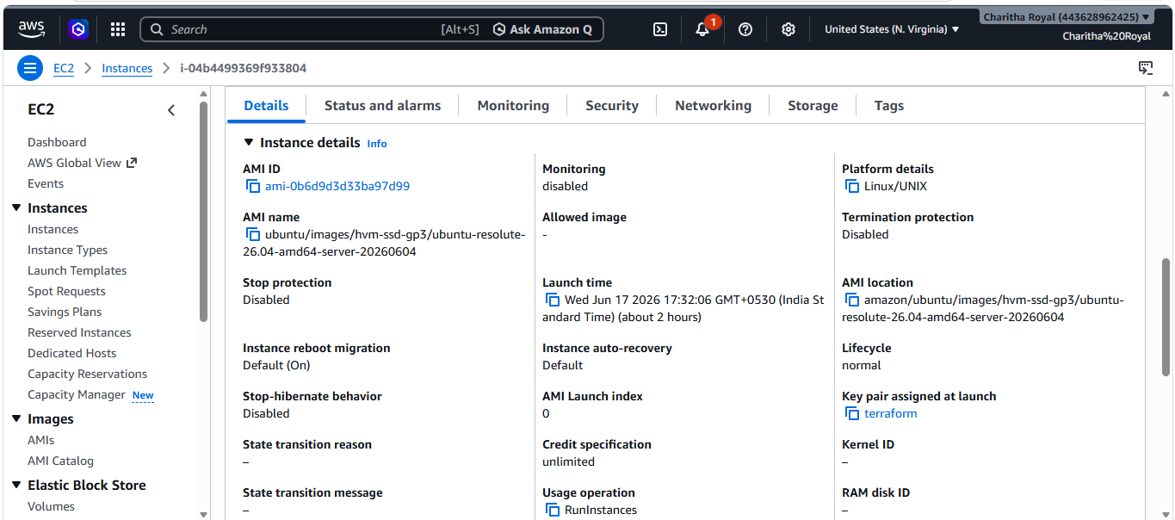
This is the script for main.tf file
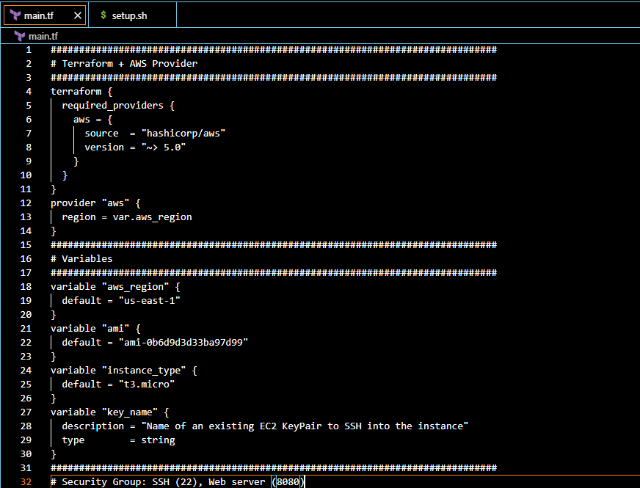
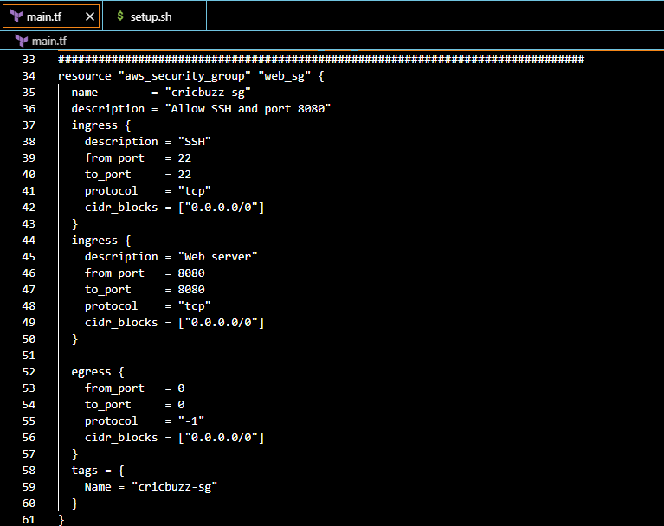
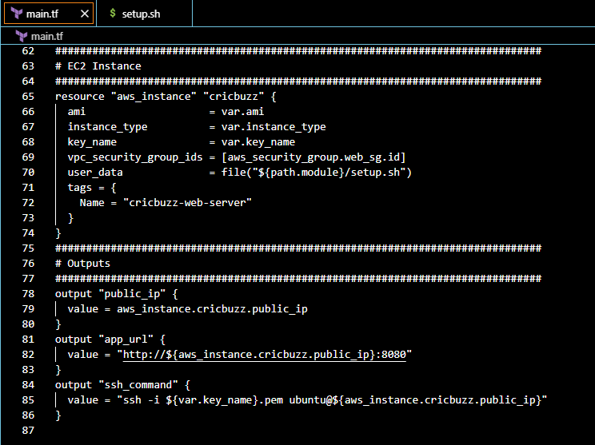
This is the script for setup.sh file
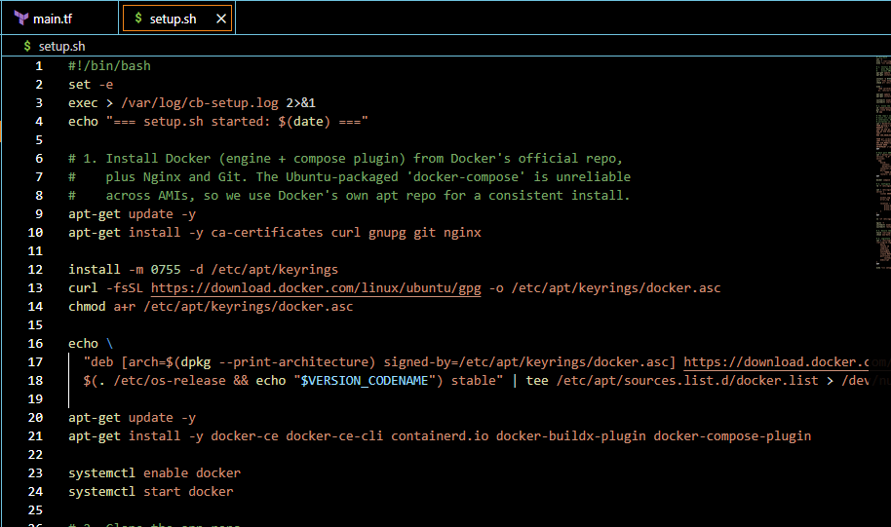
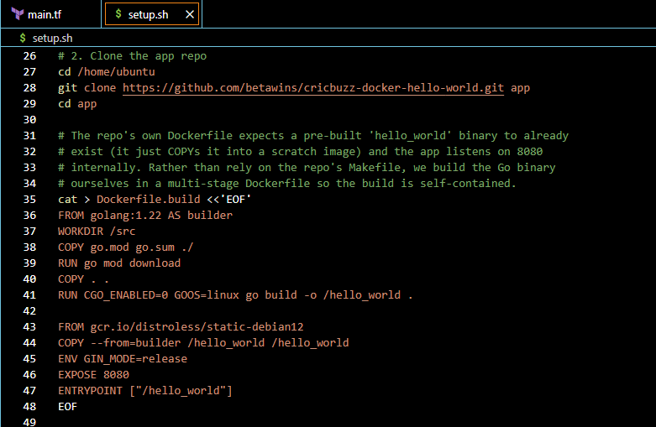
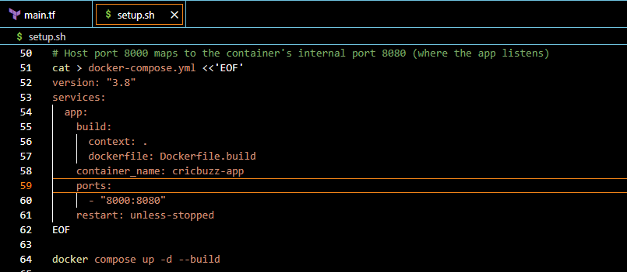
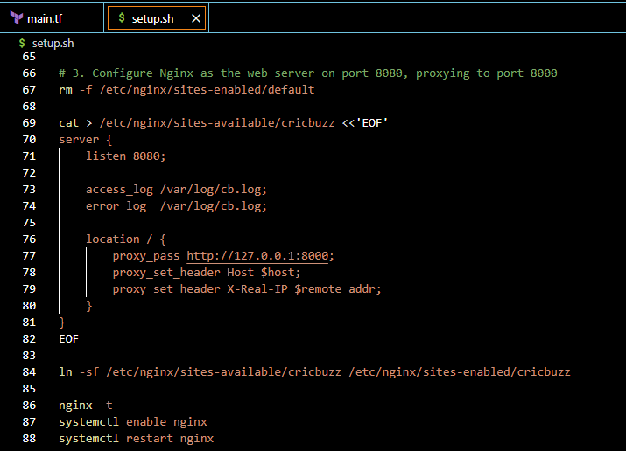
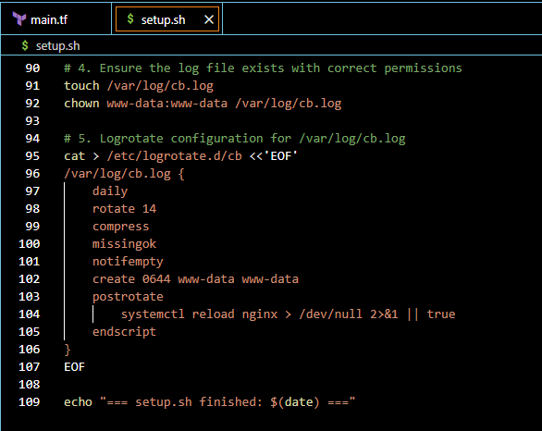
terraform init
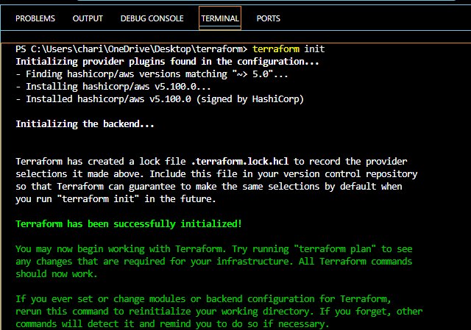
terraform validate
terraform fmt
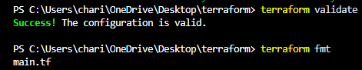
terraform plan
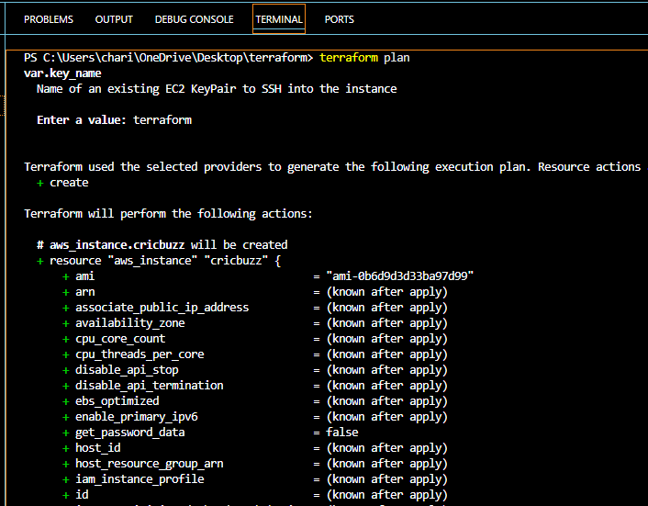
terraform apply
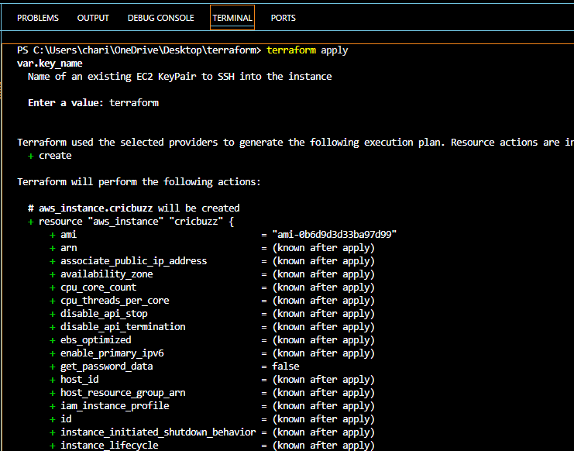
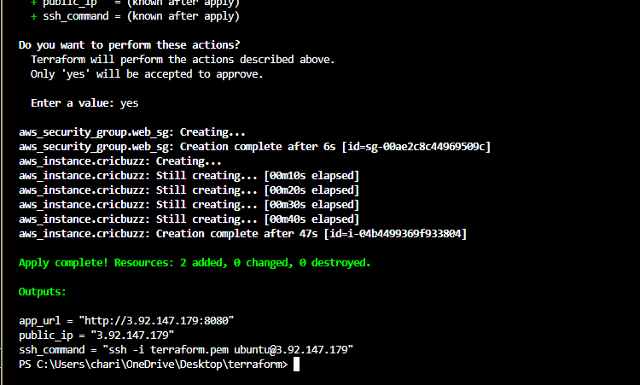
app_url = "http://3.92.147.179:8080"
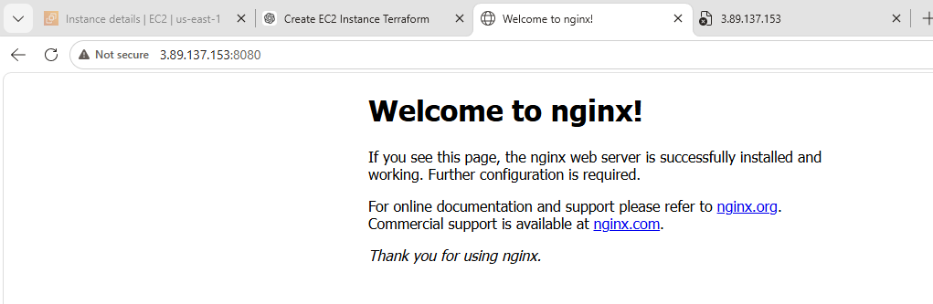
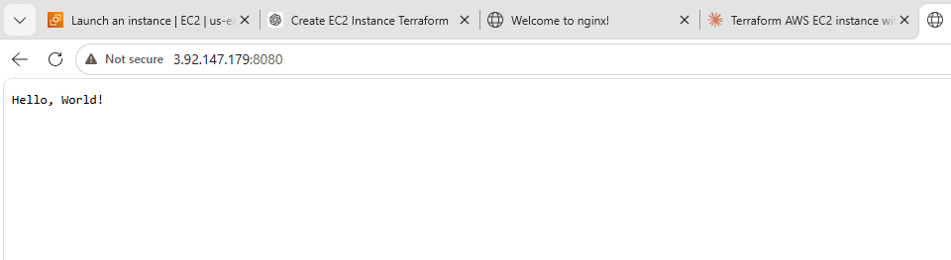
5. Configure to Save the Logs in the location /var/log/cb.log
6.Write the Log rotate configuration for the above file
We are able to see the logs
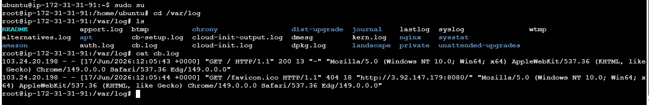
Log rotate output
